**Worksheet 2.3 or 6**

**Student Name:** Vivek Kumar **UID:** 21BCS8129

**Branch:** BE-CSE (LEET) **Section/Group:** ON20BCS-809/A

**Semester:** 4th Sem **Date of Performance:** 01/04/2022

**Subject Name:** MPI Lab **Subject Code:** 22E-20CSP-253

**1. Aim/Overview of the practical:**

1. Shift Left 8-bit number by 1bity.
2. Shift Left 8-bit number by 2bit.

**2. Task to be done:**

Write an 8085 Microprocessor program to shift left of 8-bit number by 1bt and 2bit.

**3. Apparatus/Simulator used (For applied/experimental sciences/materials-based labs):**

1. 8085 Jubin simulator version 2 (Microprocessor Simulator)
2. Java (jdk/ jre1.8.0_321)

**4. Algorithm/Flowchart (For programming-based labs):**

**Algorithm to find left shift of 8-bit number by 1bit without Carry:**

1. Load the data to the Accumulator from 2000 memory address.
2. Do the left shift using RLC.
3. Store the 1bit left shifted value from Accumulator to 2001 memory location.
4. End the execution using HLT.

**Algorithm to find left shift of 8-bit number by 1bit with Carry:**

1. Load the data to the Accumulator from 2000 memory address.
2. Set the carry flag as 1 using STC.
3. Do the left shift with carry using RAL.
4. Store the 1bit left shifted value from Accumulator to 2001 memory location.
5. End the execution using HLT.

**Algorithm to find left shift of 8-bit number by 2bit without Carry:**

1. Load the data to the Accumulator from 2000 memory address.
2. Do the left shift with carry using RLC 2 times.
3. Store the 1bit left shifted value from Accumulator to 2001 memory location.
4. End the execution using HLT.

**5. Description/ Code:**

**Program to find the left shift of 8-bit number by 1bit without carry:**

# ORG 1000H

LDA 2000

RLC

STA 2001

HLT

# ORG 2000H

# DB 55

**Program to find the left shift of 8-bit number by 1bit with carry:**

# ORG 1000H

LDA 2000

STC

RAL

STA 2001

HLT

# ORG 2000H

#DB 55

**Program to find the left shift of 8-bit number by 2bit without carry:**

# ORG 1000H

LDA 2000

RLC

RLC

STA 2001

HLT

# ORG 2000H

#DB 55

**6. Result/Output/Writing Summary:**

**Program to find the left shift of 8-bit number by 1bit without carry:**

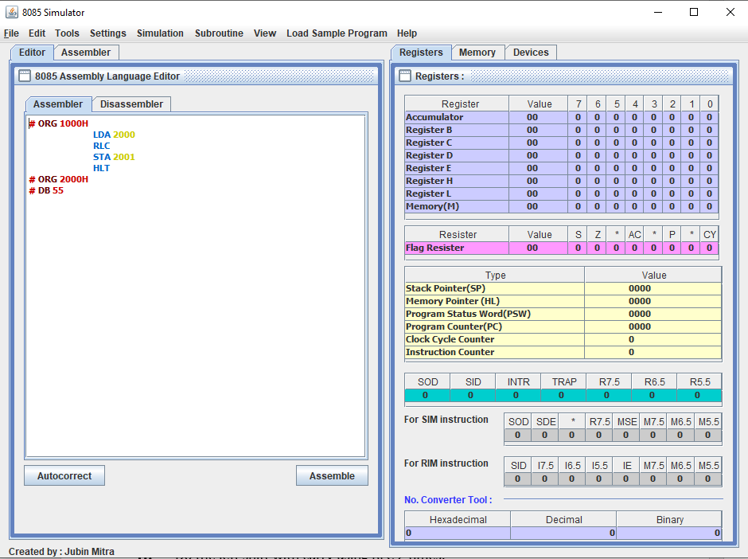

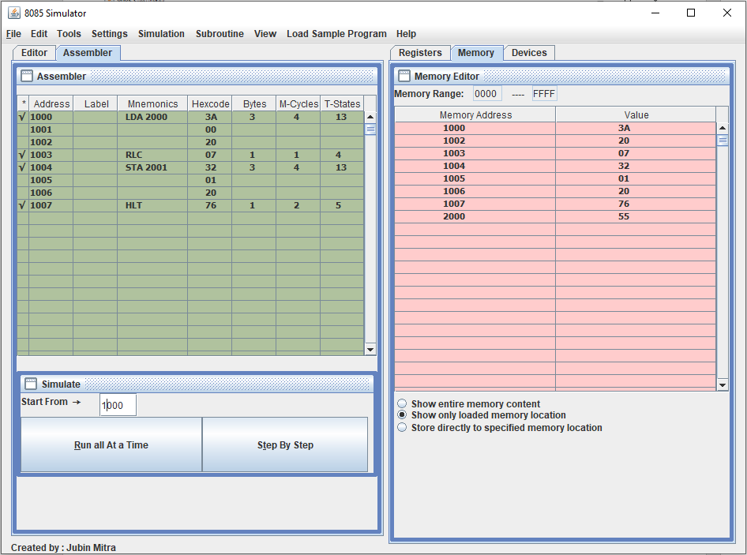

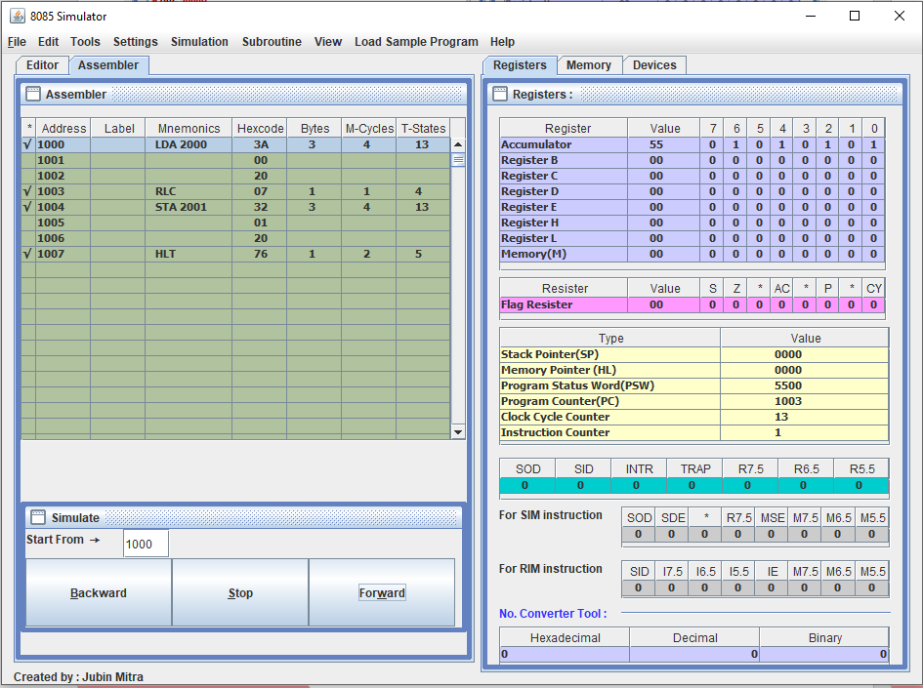

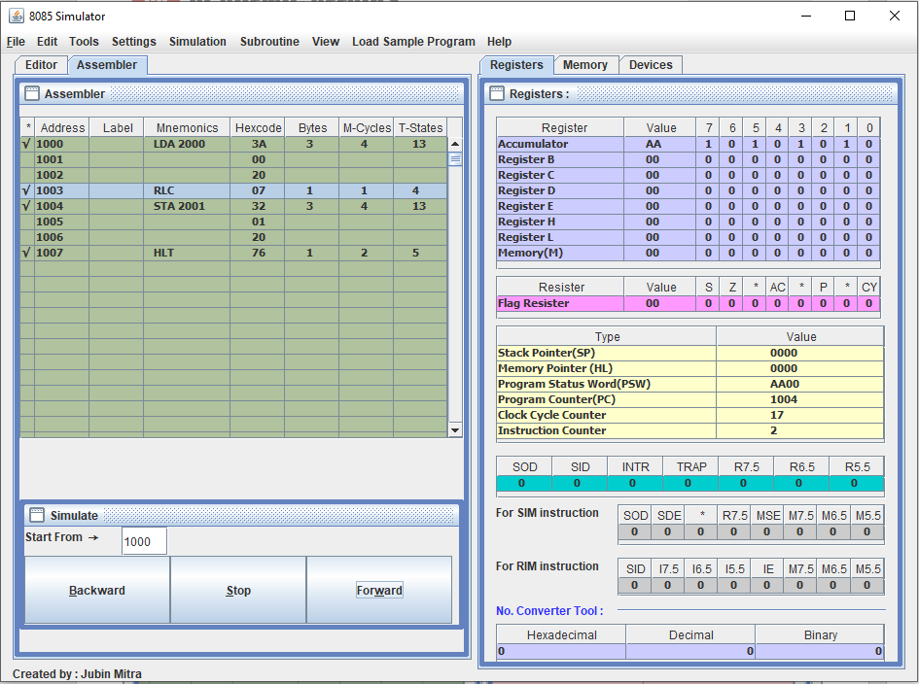

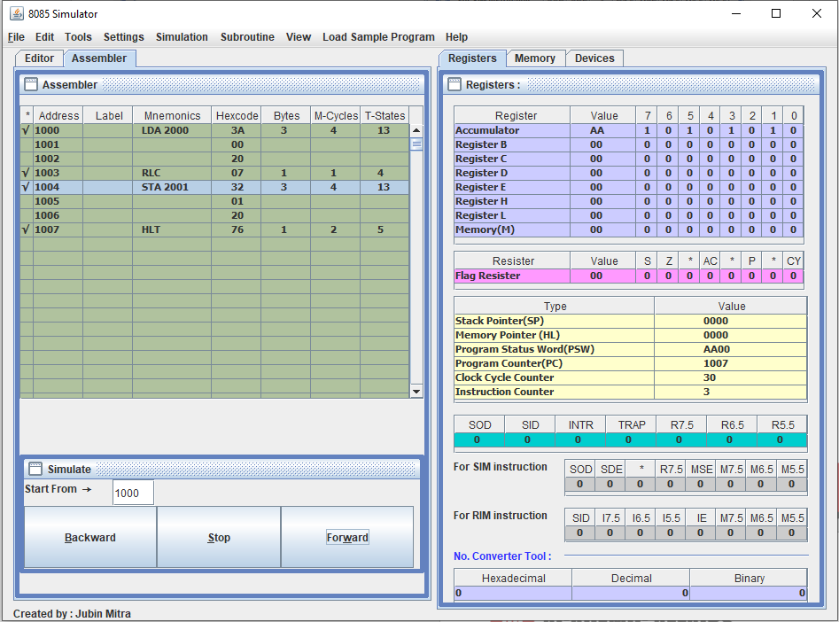

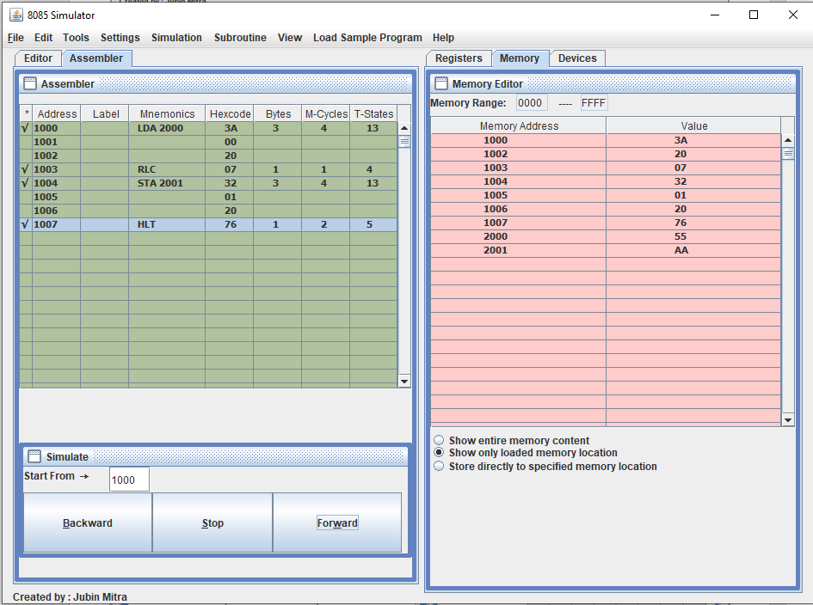

**Program to find the left shift of 8-bit number by 1bit with carry:**

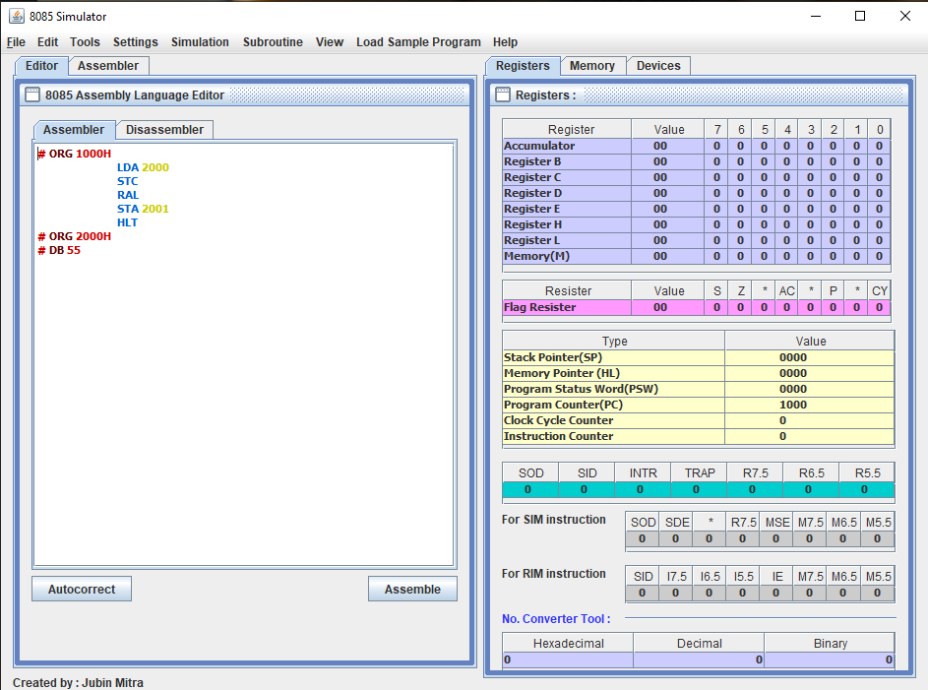

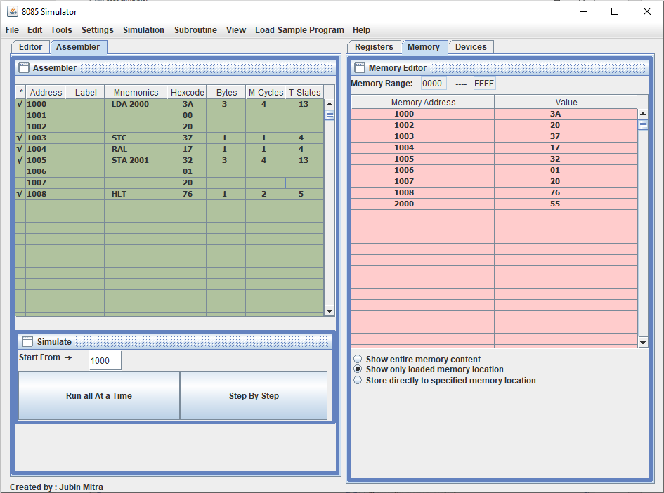

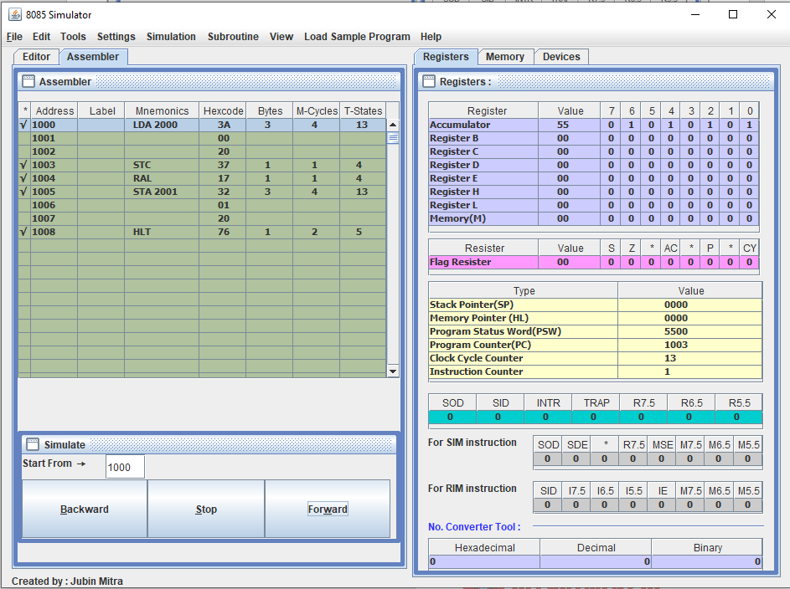

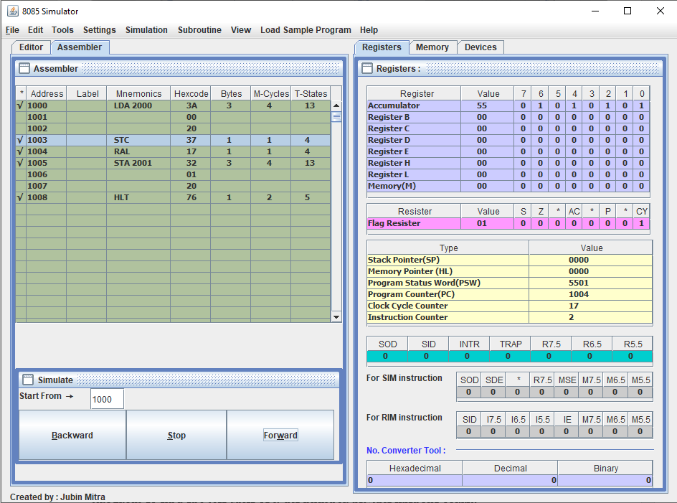

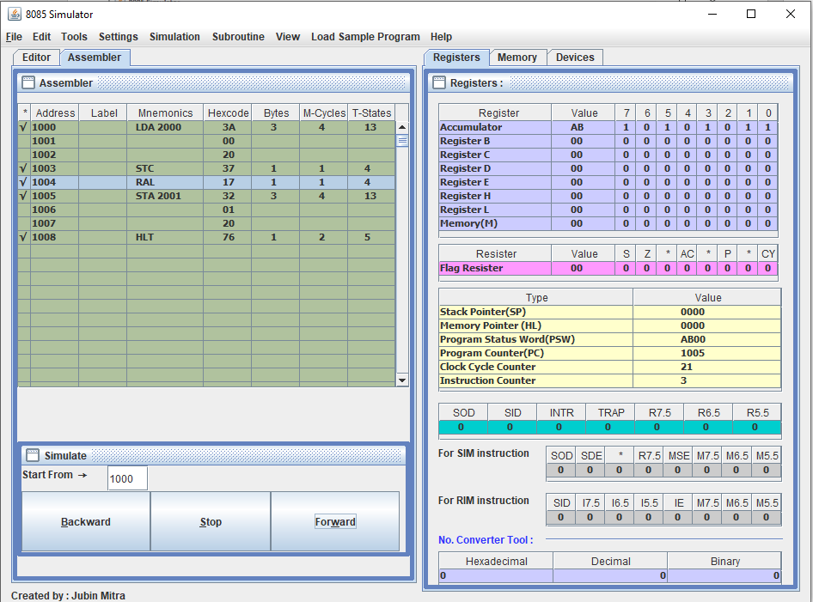

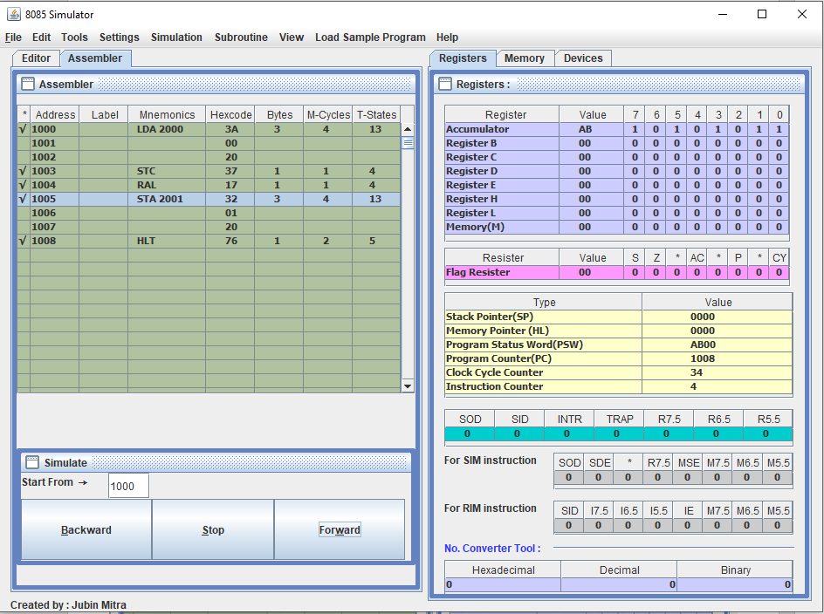

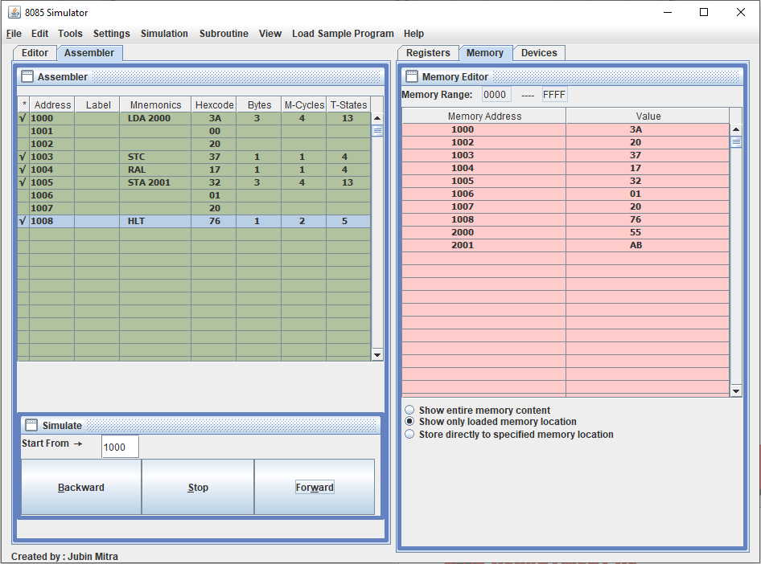

**Program to find the left shift of 8-bit number by 2bit without carry:**

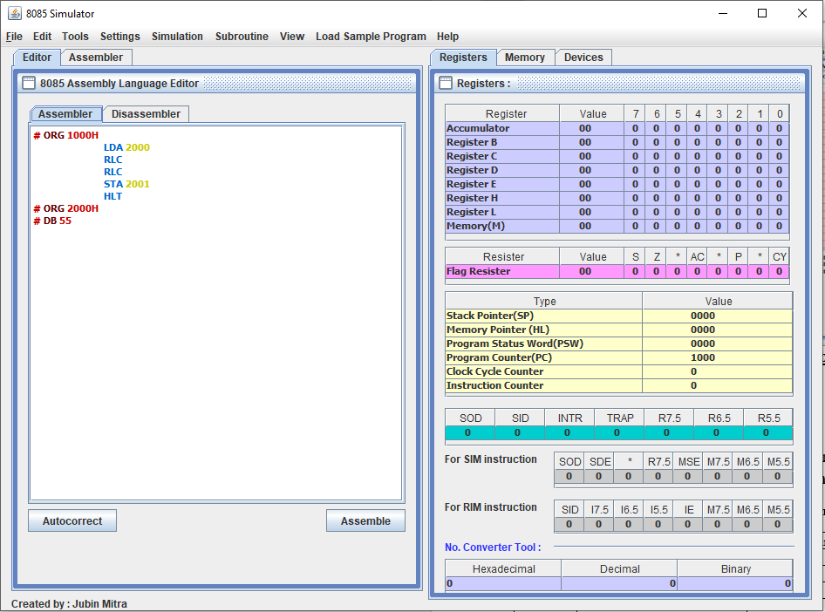

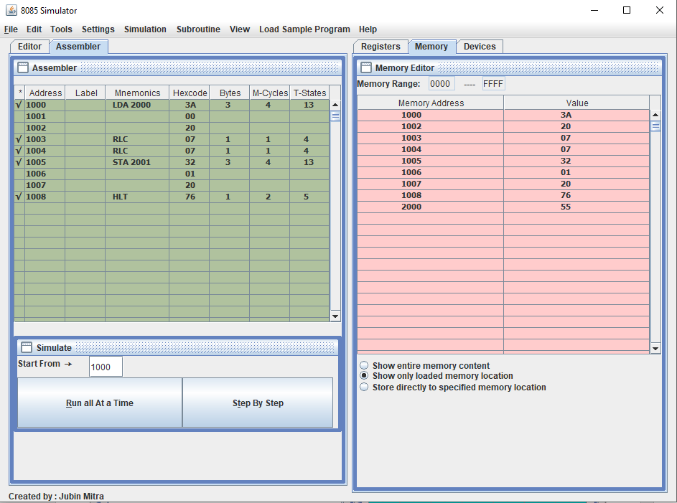

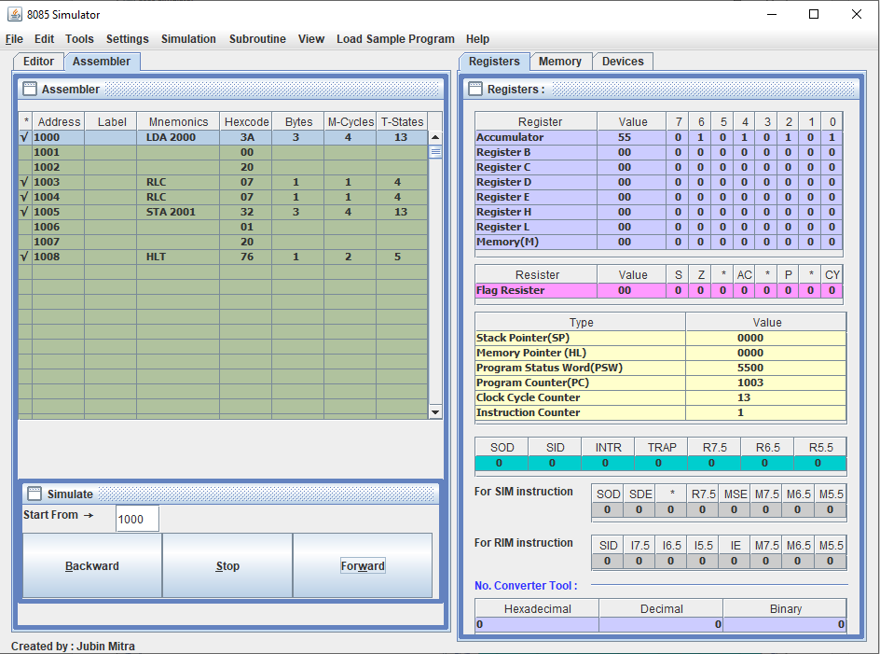

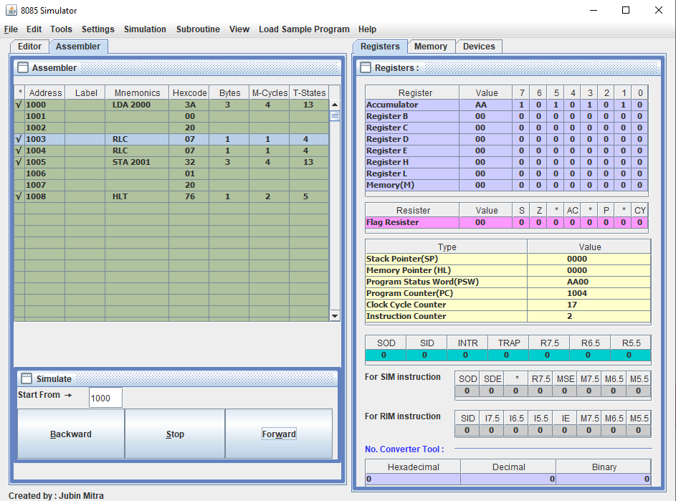

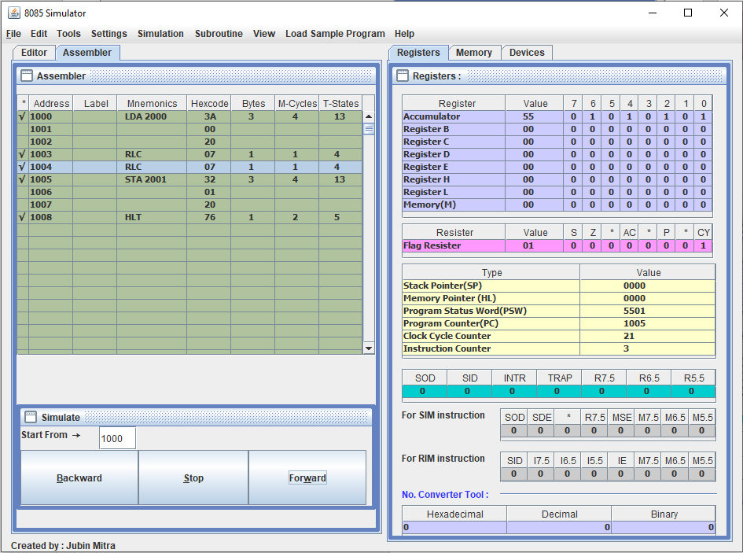

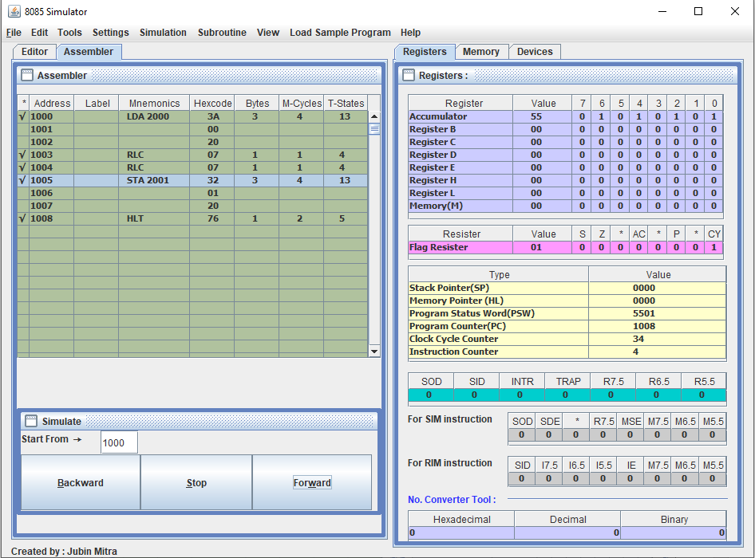

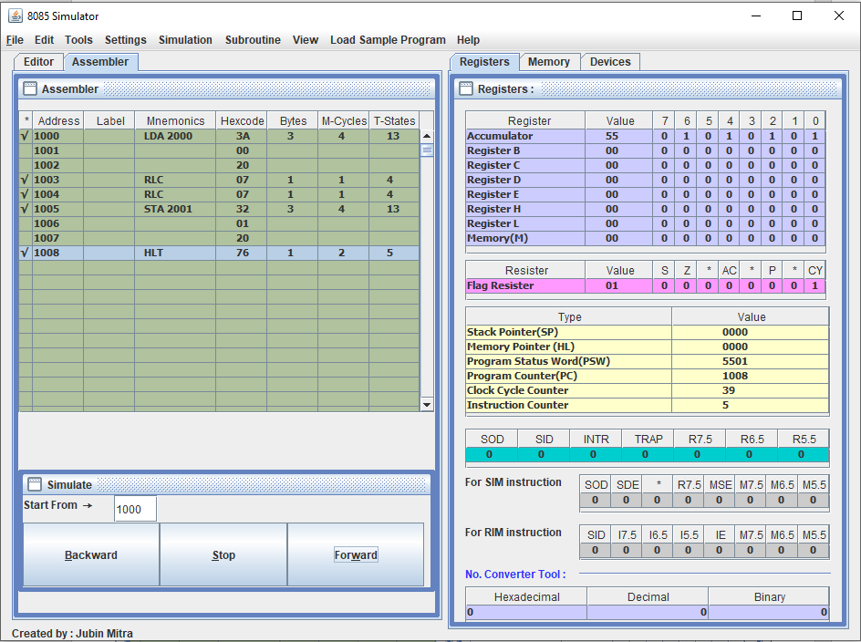

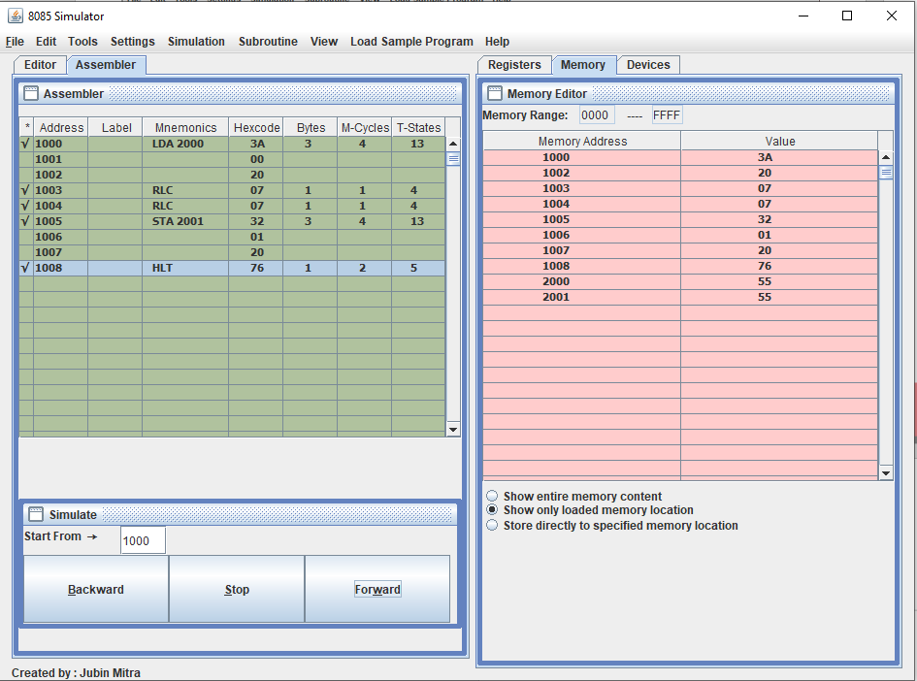

**Learning outcomes (What I have learnt):**

1. Learnt to find the 1’s complement of 16-bit number.
2. Learn to find the 2’s complement of 16-bit number.

**Evaluation Grid (To be created as per the SOP and Assessment guidelines by the faculty):**

|  |  |  |  |
| --- | --- | --- | --- |
| Sr. No. | Parameters | Marks Obtained | Maximum Marks |
| 1. |  |  |  |
| 2. |  |  |  |
| 3. |  |  |  |
|  |  |  |  |